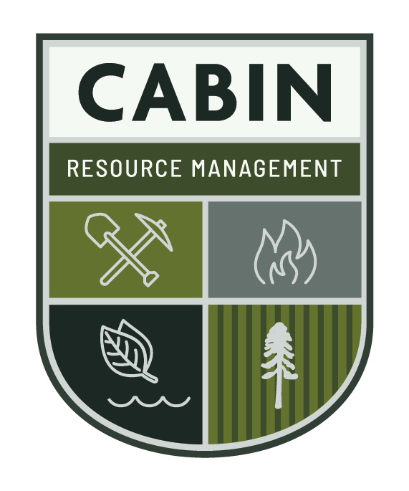
Cabin Resource Management Safety Plan

Revision Date: October 24, 2020

Cabin 2020 Safety Plan
Prepared By:  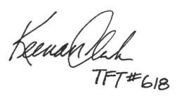  Keenan Clark, TFT, Cabin Cert.  Safety Coordinator | JOHSC Member:  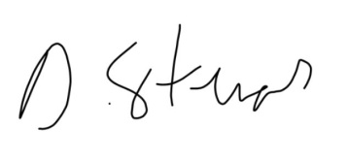  Dave Stevens, TFT  Castlegar Safety Representative
Date Signed (MDY): | Date Signed (MDY):
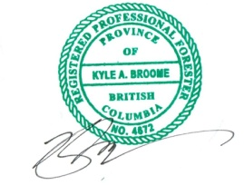  Ownership Representative:  Kyle A. Broome, RPF  Principal | JOHSC Member:  Stephanie von Loessl  Kelowna Safety Representative
Date Signed (MDY): | Date Signed (MDY):

JOHSC Member
Trevor Rasmussen, RFT
Trails Manager
Date Signed (MDY):

Contents
Cabin Resource Management Safety Plan 1
1.0 Policy Statement 6
2.0 Establishment of Cabin’s Safety Plan 6
2.1 Joint Occupational Health and Safety Committee 7
3.0 Vision, Mission and Values 8
3.1 Vision 8
3.2 Mission Statement 8
3.3 Values 8
4.0 Safety Goals and Objectives 2020 9
5.0 Safety Orientation 11
5.1 Visitors 11
5.2 New and Returning Workers 11
5.3 New or Young Worker Policy 11
5.4 Contractor Selection Policy 12
6.0 Monthly Company Safety Meetings 13
7.0 Responsibilities 13
7.1 Employer and Safety Committee 13
7.2 JOHSC Safety Innovations Responsibilities 14
7.3 Supervisor Responsibilities 14
7.4 Employee Responsibilities 14
8.0 Safety Policies 16
8.1 Bullying and Harassment 16
8.2 Smoking Policy 16
8.3 Drug and Alcohol Policy 16
8.3.1 Employee Expectations: 17
8.3.2 Drug and Alcohol Testing 17
8.3.3 Medications 18
8.4 Disciplinary Corrective Action 18
9.0 General Safety Procedures 20
9.1 Daily Safety Procedure 20
9.2 Personal Protective Equipment 20
9.3 Bear Spray 21
9.4 Check In/Out Procedure 22
9.5 After Estimated Time of Return 22
9.6 Working Alone Policy 23
9.7 Rules of the Road 23
9.7.1 Transport 23
9.7.2 Commercial Vehicles 24
9.7.3 Vehicles Inspections 24
9.8 Lock Out Procedure 24
9.9 Radio Usage 25
9.10 Firearms 25
9.11 Standard Operating Procedures 26
10.0 Upset Conditions 27
10.1 Natural Weather Events 27
10.1.1 Windstorms 27
10.1.2 Hot Weather 28
10.1.3 Fire 28
10.1.4 Avalanche 29
10.2 Wildlife Encounter Procedure 29
10.2.1 Bears 29
10.2.2 Cougars 31
10.3 Biological Hazards 32
10.3.1 Infectious Diseases 32
10.3.2 Sharps Identification and Disposal 32
11.0 Emergency Procedures 33
11.1 Responding to Emergencies 33
11.2 Air Evacuation 34
11.3 Rescue Procedure for Missing or Late Personnel 34
11.4 Fatality Emergency 35
11.5 Office Emergency Procedure 36
11.6 Emergency Safety Drills 36
11.7 Roles and Responsibilities 37
12.0 Investigations 38
13.0 Staff Competency and Professional Development Plans 39
14.0 Health and Wellness 40
14.1 Fatigue 40
14.2 Injury/Disability Management 40
Appendix A. LIABILITY POLICY 42
Appendix B. WHMIS 2015 Pictograms 44
Appendix C. First Aid Kit Checklist 45
Appendix D. PPE Inspections 46
Does Your Hardhat Need Replacing? 46
Appendix E. Radio Channel Frequencies 47
Appendix F Inspection Reporting Procedure 49
Appendix f. Incident Reporting Procedure 50
Appendix g. Emergency Contact List Emergency 51
Appendix h. WSBC First Aid Requirements 53

Policy Statement
Ensuring that all people employed through Cabin Resource Management (CRM) come home safely every day, is our highest priority. In keeping with this philosophy, CRM is committed to creating and maintaining a safe work ethic amongst staff with the aim of preventing work related accidents and incidents. This will be achieved by establishing safe work standards, providing a safety orientation session for every CRM employee where all safe work standards are reviewed, employing standard operating procedures (SOPs), maintaining safe working conditions and fostering a safe work ethic. This in turn will foster a positive and healthy working environment, with safety conscious employees.
A key element in creating a safe working environment is developing a clear and concise safety plan and making the plan accessible to all employees. It is the duty of each, and every person employed by our company to adhere to this safety plan and to carry out each specific task in a safe and intelligent manner. Managing activities that pose a risk and maintaining awareness of safety at all times is the primary approach that Cabin will undertake. Our management and supervisory staff are committed to lead and demonstrate by example. However, it must be recognized that ultimately everyone on the job must take personal responsibility to prevent injury to themselves and others.

We strictly adhere to:
- Ensuring that all employees have the right to refuse unsafe work.
- Operating in accordance with CRM safety standards in addition to all applicable regional, provincial, and national; health and safety laws, regulations, and codes and standards.
- Promoting and improving the safety knowledge and awareness of all employees through in-house, and external training where applicable
- Maintaining a clean and safe working environment.
- Informing each employee that they will take personal responsibility for their own safety and the safety of others.

Establishment of Cabin’s Safety Plan
- CRM Safety Plan has been established for all employees and dependent contractors and includes input and feedback from all staff. Terms of reference for the safety plan include Clients standards, BC Forest Safety Council guidelines, WorkSafeBC Regulations and other information and organizations as applicable.
- CRM has produced this document and will continue to revise and improve it as the foundation of our safety program. The safety plan will be reviewed and updated annually, with additional revisions taking place throughout the course of the year.
- All employees and subcontractors completing work on behalf of CRM will read the most current copy of the Safety Plan, sign off on their understanding of the document, and complete a safety pre-work with a Principal, Safety Coordinator, or JOHSC member prior to commencing work

Joint Occupational Health and Safety Committee
- The JOHSC Committee will be no fewer than four regular members.
- It must consist of employer representatives and worker representatives.
- Employer Representative (Principal or Partner)
- Safety Coordinator (Worker Rep.)
- Urban Forestry Representative (Employer or Worker Rep.)
- Development Representative (Worker Rep.)
- Female Employee Representative (Worker Rep.)
- A minimum of half the JOHSC members must be worker representatives. At no point can there be more employer representative then workers.
- Company safety meetings will be held monthly. An additional safety meeting document will be provided to all staff and reviewed with crews by their managing supervisors. Physical meetings will be attended by a minimum of one employer representative and two worker representatives.
- The JOHSC will regularly monitor, evaluate and improve upon safety standards. This will be accomplished through monthly JOHSC meetings, additional safety training, and annual updates to the Cabin Resource Management Safety Plan.
- Input and suggestions from all staff for improving the safety plan and working procedures are encouraged and always welcome.

Vision, Mission and Values

Vision
We are the most innovative, respected and successful resource management company in BC.

Mission Statement
At Cabin Resource Management, this is who we are and this is what we do:
- Work Safely | - Create and innovate
- Respect the forest ecosystem | - Strive for excellence
- Love what we do | - Seek and overcome challenges
- Exceed expectations | - Deliver on commitments
- Continually improve | - Work as a team

Values
Excellence – We always strive to deliver the highest quality services and products that provide maximum benefits to clients.
Adventure - We seize opportunities to build our character, though it may push me outside our comfort zone. This allows me to experience life to its fullest.
Integrity – We are honest and commit to deliver what we promise. We do not sacrifice our principles for the demands of clients or other agencies/authorities we work with.
Balance - We have a balanced approach to life, remembering that our family, social, physical and spiritual aspects are just as important as financial and intellectual.
Fun – We view our life as a journey to be enjoyed and appreciated, and we create an atmosphere of fun and happiness so all around us enjoy it as well.
Adaptability - We incorporate new ideas and innovative approaches to solving problems and delivering on commitments to clients. We realize that to adapt is to prosper.
Success - We totally focus our thoughts, energy and passion on the successful outcome of whatever we are doing.
Team Work - We respect an individual’s unique character, but know that when we work together as a team, we will achieve better results and have a better experience.
Education - We seize opportunities to learn, grow and master, so that we can constantly improve. We enjoy sharing knowledge with my team and clients, and mentor those less experienced, allowing them to improve.

Safety Goals and Objectives 2020
- Create a safe, healthy and productive working environment.
- Honour our commitment to the Health & Safety Accord of the BC Forest Industry.
- Pass yearly BCFSC audits and exceed the minimum requirements.
- Work towards an objective of reduced incidents and close calls on a year over year basis.

To achieve these goals Cabin has established the following objectives:
- Increase employee engagement through monthly meetings, minimum reporting targets of 1 form per crew per week.
- Develop a more integrated relationship with external parties (Clients, RCMP, Conservation Officers, etc.) to be better able to respond to upset and emergency conditions.
- Utilize new technology to better involve and integrate staff members to engage in safety (e-mail, automatic mailer, easy fill forms, etc.)
- Develop a new and young driver evaluation/ranking system.
- Install Safety Bulletin Board with internal and external alerts and most up to date safety bulletins.
- Continue to complete and submit vehicle and mobile equipment checklists and submit completed forms monthly.
- Perform and evaluate at least one safety drill in the field per crew.
- Retain a minimum of one employee trained in proper DNA sampling techniques for Drug and Alcohol testing.
- Conduct equipment audits, including yearly hard hat inspections.
- Update Emergency Response Plans Yearly.
- Update SOPs to increase accessibility by employees and include repetitive strain injury components.
- Review annually and improve CRM Safety Plan, the policy statement and objectives defined in this safety plan. General adherence to the safety plan will be reviewed at the monthly safety meetings. CRM is committed to resolving any issues arising during the safety meetings in a timely fashion.
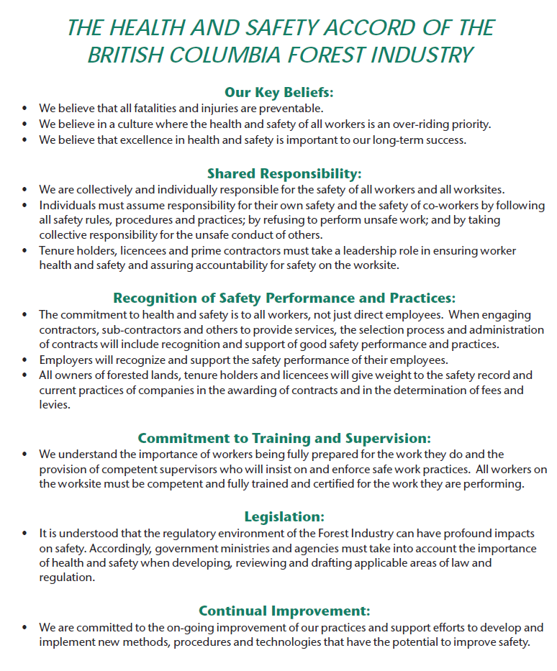

Safety Orientation

Visitors
- All visitors must sign in and sign out when entering or leaving the office or work site.
- Office sign in sheet is located at the entrance next to the sign out board.
- Safety Orientation will be provided to all visitors to the work site, office staff will direct any visitors and their course of action in the event of an office emergency.
- Orientation for visitors must include evacuation routes, and evacuation procedures/ emergency response plan (ERP).

New and Returning Workers
- Safety Orientation will be provided to all new employees as well as returning employees that have been away for 8 weeks or more.
- Orientation will occur within the first week of work for new employees or the first week back for returning employees.
- The orientation training for new and returning workers will include a review of worker rights, all CRM policies, applicable standard operating procedures (SOP) for position related tasks, reporting documents and procedures, required and additional PPE, and Workplace Hazardous Materials Information System (WHMIS 2015). These sessions allow CRM to advise returning staff on new safety policies and procedures.
- Each employee, or subcontractor will fill out an orientation checklist, and sign off on the completion once the orientation is completed.
- Formal first aid training will be made available for senior and mid-level staff who will be acting first aid attendants on the jobsite.
- A list of all emergency contacts and relevant safety training completed by each employee will be maintained and updated annually.
- CRM realizes that safety training is a dynamic process and is thus committed to integrating review and analysis sessions into safety meetings when significant incidents and accidents occur.

New or Young Worker Policy
Workers with less than one year of experience and workers under the age of 25 are more likely to have injuries. In order to reduce the safety risks associated with new and young workers Cabin has the following policies:
- Supervisors must be informed of new or youngers in their crew.
- New or young workers will receive monthly employee audits and assessments.
- New workers will be required to wear safety glasses as a part of their PPE (section 9.3).
- New and young workers must be vetted through the recruitment process with face-to-face interviews and reference checks.
- On-boarding and in-house office training must occur before the new worker heads out to the worksite. It includes but is not limited to:
- Review of this Safety Plan
- Review of Vision-Mission-Values
- Review and signing of Employment Agreement
- Assessment and provision of PPE
- Completion of Safety Orientation
- Review of Check-in/Out Procedure
- Review of Emergency Plan for Office
- Review of Employee Manual
- Completion of Par-Q Form and Personnel Data Sheet
- Provision of a up to date Drivers Abstract
- Copies of all relevant safety certifications
- Field training will occur during the first week of work. Any additional on-going training will take place throughout the entirety of the field season
- Employee Audits on new and young workers will occur at a greater frequency.

Contractor Selection Policy
Cabin has long standing relationships with both independent and dependent contractors. To ensure the safety of our contractors we implement the following policies for existing and new contractors:
- Review of contractors’ BC Forest Safety Council, or WorkSafeBC status where applicable.
- Provide Cabin with information pertaining to any hazards or dangerous goods that will be brought to the worksite.
- Regular meetings and pre-works with a company principle to ensure compliance.
- Provision of proof of insurance
- Contractors must provide a up to date drivers abstract (if operating Cabin supplied vehicles)

Monthly Company Safety Meetings
All employees must participate in monthly company safety meetings either in the office or in the field as directed by the Safety Committee. The meetings will carry out the following functions:

- Identify any potential hazards or inadequacies, and then discuss solutions or corrective actions.
- Promote safety awareness and educate others on safety procedures.
- Plan for safety training as required.
- Discuss relevant safety issues both past and present.
- Review any recent Close Calls/Incidents.
- Review any relevant accident/incident investigations as distributed by Safety Committee.
- Attendance will be documented via a meeting check in sheet attached to the bottom of the safety meeting mailer.

Responsibilities
It is the responsibility of each person to ensure that they, as well as fellow employees, follow proper safety procedures in order to prevent any injuries or illness.

Employer and Safety Committee
CRM has the following health and safety responsibilities to:
- Create and maintain a workplace which supports and protects our mental health and well being
- Ensure all employees must read, understand, and work in a safe manner in accordance with the standards defined in the Cabin Resource Management Safety Plan.
- Ensure that controlled products are labelled or identified, Safety Data Sheets (SDS) are available, and workers receive the appropriate WHMIS (2015) worker education.
- Investigate all recordable incidents, and close calls as per WorkSafeBC regulations.
- Ensure that all work crews have a valid Occupational first aid, Level 1 certified team member and carry the minimum required first aid equipment on their persons and in the company vehicle while at the worksite.
- A copy of all First Aid attendants’ certifications will be retained by CFS if the attendant does not have a hard copy on them at the worksite.
- Professional Development Plans will be tailored to advise, coach and evaluate the performance of all supervisors and workers (section 13.0).

JOHSC Safety Innovations Responsibilities
- Prior to the start of each field season the JOHSC Safety Innovation Team will conduct a critical examination of our Safety Plan, analyze ideas, and recommendations and continual improvement points from yearly BC Forest Safety Council Audits. The JOHSC will then determine how to implement new safety ideas and draft them into the Cabin Resource Management Safety Plan.

Supervisor Responsibilities
It is the responsibility of all leadership positions to:
- Ensure all operations are conducted in accordance with CRM Safety Plan and Occupational Health and Safety (OHS) Regulations and/or any specific client requirements.
- Ensure every truck will have regular truck inspections completed, and an inventory of all required safety equipment completed.
- Report any Incident, close call, equipment/property damage, lost time, accidents or incidents as per Safety Reporting Procedure (Appendix F).
- Ensure that all employees are aware of potential hazards associated with each task or job site.
- Maintain all equipment and be aware of potential hazards associated with each piece of equipment.
- Conduct Employee Audits to evaluate the compliance level of all staff in meeting of the objectives and commitment levels defined in the company safety plan and to gain suggestions for improvement.
- Complete and submit monthly personal equipment audits for the respective crews under their supervision.

Employee Responsibilities
It is the responsibility of each employee to:
- Report to a company principal or project manager any health condition, prescription medication you require or any other important information regarding your health or safety prior to commencing work. A basic medical form will be maintained for each employee and kept on file in the CFS office.
- Fully comprehend the SWP/SOP of performing a particular task prior to commencing work and ensure that procedures are followed.
- Know where supplemental first aid equipment, SWP/SOP information and emergency numbers are found.
- Review applicable ERP’s and know the procedure of summoning help to the work site prior to commencing work.
- Ensure all mobile equipment is always operated under control and that all applicable rules and laws are obeyed (speed limits, helmets on quads, etc.).
- Report any unsafe working conditions, unsafe tasks, or faulty equipment promptly to supervisors.
- Report all hazards, injuries, accidents, close calls, property damage to supervisors and the JOHSC- regardless of severity. Document all Incidents or close calls utilizing an Incident Reporting Form. All forms can be found on the Q: Drive _Safety_ >! Safety Forms. See Incident Reporting Procedure (Appendix G) for greater detail.
- Report both positive and negative safety observations, to support good practices, and foster a culture of continual improvement
- OHS Regulation 4.20 will be strictly enforced. “A person must not enter or remain at any workplace while the person's ability to work is affected by alcohol, a drug or other substance so as to endanger the person or anyone else.” Any form of impairment (drugs, alcohol, or other substances) is not permitted. Suspected impairment, either drugs or alcohol will result in immediate suspension by the supervisor or project manager. See 8.3 Drug and Alcohol Policy for greater detail.

Safety Policies

Bullying and Harassment
It is a shared responsibility for all employees to prevent bullying and harassment. Bullying and harassment will not be tolerated. If bullying or harassment should occur, please report the incident to the project manager or a company principal.
Bullying and harassment includes, but is not limited to:
- verbal aggression or insults
- calling someone derogatory names
- harmful hazing or initiation practices
- vandalizing personal belongings
- spreading malicious rumours

Smoking Policy
As per Cabin Resource Management Liability Policy (Appendix A):
“All employees are prohibited from smoking or lighting fires of any kind outside of a strictly controlled environment (i.e. camp stove) while on the job or job site.”
Controlled areas are considered to be the parking lot associated with our Vernon and Kelowna, and Nelson offices. When working in the office, smoking is only permitted in these controlled areas or in the employee’s personal vehicle.
When doing field work, a controlled area is either a landing, logging road, or an area of the forest that is denuded of forest vegetation. If smoking occurs outside of a controlled area in the forest, the following procedure must be used:
- smoking is not permitted in the forest during fire danger class 4 or 5 (extreme or high) conditions
- smoking must not occur when winds are moderate or severe
- smoker should find the most fireproof location in the forest before lighting up, (i.e. open areas with non-vegetated ground/rock)
- all cigarettes and matches MUST be disposed of in a sealed container to be stored with the smoker and brought to the truck at the end of the field day
- cigarettes and matches will NEVER be disposed of in the forest

Drug and Alcohol Policy
To ensure that our workers – including dependent contractors and their subcontractors – work in a safe environment, Cabin has adopted a Drug and Alcohol Policy to address the variety of concerns around Workers who engage in substance abuse who constitute an increased risk to others, themselves, the public, environment, to our reputation and property, and to our clients. This policy, in conjunction with education, training and testing will help us to meet our obligations and protect all workers from the consequences of impairment due to substance use or abuse.
Workers breaching this policy will be referred to a Substance Abuse Professional and may be subject to corrective action, up to and including termination of employment / or contract.
Each Worker will have access to a digital copy of the Policy on the Q: Drive: _Safety_ > Drug and Alcohol Policy, and will be asked to sign and return. Additionally, all Workers are required to complete refresher training annually. Workers who have concerns or questions regarding the Policy should speak to their Project Manager or Safety Coordinator.

Employee Expectations:
- Report for duty free, and remain free, from any adverse effects from alcohol, drug, mood altering substances (including Cannabis), as well as prescribed or over counter medications.
- Before a violation of the Requirements, report to supervisor, seek advice and follow
appropriate treatment if they have a current or emerging drug or alcohol problem
and follow recommended monitoring programs after attending treatment.
- Co-operate with any investigation into a suspected violation including any
request for drug and alcohol testing.
- Co-operate with any work modification related to safety concerns
- Individuals who are on standby must be fit for duty and remain in compliance
with these Requirements.
- If a Worker who is not fit for duty for any reason – including drugs, alcohol, mood altering substances or medications – is requested to perform services he or she must
inform the Supervisor / Project manager that he or she cannot accept
that assignment.
- In any situation where Workers are tested as a result of application of these
Requirements, the Worker being tested must confirm in writing that their drug
and alcohol test results will be released to the Company’s Designated Program
Administrator and employer.

Drug and Alcohol Testing
Drug and Alcohol testing may be carried out if a Triggering Incident occurs, Post Incident, Reasonable Cause, Return to Duty, Follow-Up and Safety Sensitive Testing. In addition to any testing that may be required, Workers reasonably believed to be in possession of Alcohol or Drugs, or Drug Paraphernalia, or reasonably believed to be using Drugs or Alcohol on the job, may be subject to a Search as defined in the Policy. All Workers must be accountable for their actions, even Workers who may have a drug or alcohol problem or dependency. After any confirmed violation, the worker will be referred for an assessment by a Substance Abuse Professional (SAP) to determine course of action post incident, including determining if a substance abuse problem exists, developing a treatment plan if required, and to verify fitness for duty. Depending on the situation, there is no automatic second chance.
Workers who provide a breath sample equal to or in excess of 0.02 BAC but below 0.04 in the first instance will be subject to investigation and may be suspended without pay for up to 24 hours. Such Workers will require a Return to Duty breath Alcohol test prior to returning to Safety Sensitive duties. Workers exhibiting signs of impairment, regardless of their breath sample results, will be subject to Drug and Alcohol testing as well and will be suspended until the Certified Laboratory test results are known.
The established limit for cannabis is 2ng/ml, a test exceeding this level will be considered impairment.
The following table outlines the cut-off levels established for workplace testing programs throughout North America.
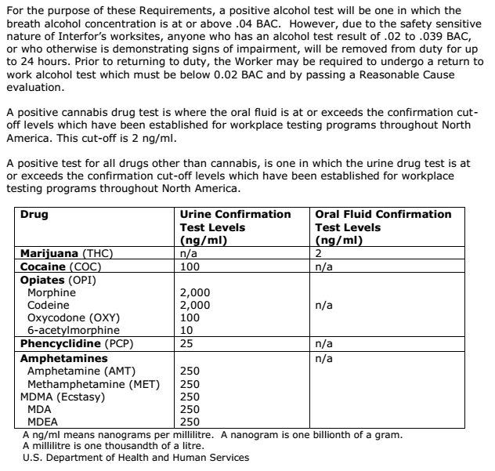

Medications
Workers are expected to responsibly use all medications, including those that are prescribed or over the counter. Workers are required to inform and confirm with their treating physician and/or pharmacist whether a medication can negatively affect their performance. Workers must take all appropriate steps to minimize associated risk. This may include using a safe alternate medication. If there is no safe alternative, workers are required to notify the supervisor if modified work is required.

Disciplinary Corrective Action
An employee may be subject to Disciplinary Corrective Action if they fail to work in accordance with written CRM Safety Plan guidelines and requirements or company safe work procedures. This may include any of the following:
- Failure to follow Daily Safety Procedure
- Failure to wear required PPE
- Failure to complete mobile equipment pre-trip checks.
- Knowingly jeopardizing their own or someone else’s safety.
- Bullying and Harassment
- Documented infractions of federal, provincial, or local laws
Additionally, staff may be subject to disciplinary corrective actions if they fail to operate Cabin equipment in accordance with Federal, provincial, and local laws. Each situation will be judged off its own merits as Cabin recognizes that some events occur outside of the realm of employee’s control. Disciplinary Corrective Action is only for when the employee knows the rules and expectations and is capable of meeting them, but chooses not to. Its purpose is not punitive, but to correct the lapse of conduct and return to the desired standard of conduct.
- First offence is an oral reminder by anyone on the crew.
- Second offence is a written reminder by a member of the management team or company safety coordinator, which is documented, and a $20 fine that will go into the company Health & Wellness budget.
- Third offence will be a minimum of one day off without pay as per the discretion of a company principal.
- The fourth offence will result in dismissal.

General Safety Procedures

Daily Safety Procedure
- No person is to continue work if he/she believes it unsafe to do so. A variety of Safe Work and Standard Operating Procedures (SWP/SOP) are located on the Q: Drive > Safety > Safety SWP’s. These will be reviewed in pertinent circumstances as required, but particularly when a new employee is involved, or the task or procedure is new to the individual.
- Compliance with all client stipulations and OHS regulations is mandatory.
- All crews going into the field must sign out prior to leaving (see section 9.4).
- Consideration for adequate safety on the job will be discussed for each separate area worked in as required (buddy system etc.). Working alone warrants special considerations (see section 9.6).
- All emergency procedures will be organized before commencement of work.
- All crew vehicles will the minimum required first aid supplies as outlined by WorkSafeBC.
- A daily observation of safety or protective equipment needs will be completed by the worksite supervisor (i.e. high visual vests and/or hard hats near heavy machinery or overhead hazards etc.) prior to work commencement.
- Handheld radios will be used to maintain contact among separate crews and on any helicopter jobs.
- All crew vehicles will have frequency lists available for all programed truck radio banks.
- Use of helicopter will require a safety meeting with the pilot prior to departure to discuss helicopter safety and pick up/drop off arrangements. Do not assume anything! The flight plan must be filed with the Aircraft Company and with the client if required.
- Common sense is required at all times. Helpful suggestions or mention of safety oversights are welcome at all times. It is expected that any omissions or failings of this document will be brought up at the next company safety meeting

Personal Protective Equipment
All employees are required to utilize proper PPE and wear the correct gear for the potential hazards associated with the job being performed. All PPE must be in good condition and will be subject to inspections throughout the field season for repair or replacement. Items such as hard hats and bear spray must be checked for expiry dates and damage, while items such as work boots, vests and seasonal clothing must be checked for wear and tear and replaced as required for individual worker safety.

All employees working the woods or remote / interface regions must have the following personal protective equipment (PPE)
- High visibility hard hat (CSA approved)
- Work boots suitable to task (caulks, high-ankle hiking boots, or steel toes)
- High-visibility vest (cruiser vest)
- BC personal First Aid kit (See Appendix C )
- Appropriate seasonal clothing (i.e. long sleeve shirt, rain gear, sun screen, toque, gloves)
- Bear spray
- VHF Two-way radio
Whistle

Additional PPE may be required depending on the scope of the project. Some additional considerations include:
- During water transport operations a life vest (PFD) must be worn by each passenger. Heavy footgear (boots) or equipment (laden vest) is prohibited from being worn.
- Helmets (DOT or applicable certification) must be worn when using ATVs or snowmobiles.
- Gloves and ear-protection are required when working with snow machines.
- Ear protection when operating or near loud equipment such as chippers, or snowmobiles.

Notice to new and young workers: protective safety glasses are mandatory PPE for new workers with less than one-year experience.

CRM will supply all snowmobile and ATV helmets, ear protection, safety glasses, first aid kits, bear spray, and whistles for employees. All remaining equipment such as hard hats, cruise vests and boots will be supplied by the employee. Subcontractors will be required to supply all their own equipment.

Bear Spray
Bear spray can be used an effective deterrent for animals such as bears, cougars, elk, coyotes, and wolves. Keep your bear spray in an accessible location, not buried in the back of your vest. When a bear charges, you may only have 2 to 3 seconds to respond.
Make sure that the bear spray is current. Bear spray typically expires after two to three years.
Bear spray is only effective when the animal is within 5m. Be aware of the wind direction when using bear spray. Aim slightly downwards just below the animal’s face to not shoot over their head. Bear spray is usually effective for only 6 to 8 seconds. Recommendation is to use short bursts at your target. Bear spray is intended to cause temporary blindness in the bear and inhibit the sense of smell, giving you a chance to get away from the bear to a safe place. For more information on wildlife see section 10.2.

Check In/Out Procedure
The check in system will be reviewed and modified, if required, prior to the start of each field season. This check in system will be established as a standard for each client and job location and will be approved at the pre-work conference with the client. Before leaving the “office” notify the project manager and your check-in reference of the following information:
- Work site location
- List of workers
- Truck to be used
- Estimated time of return.
Crews will utilize a combination of whiteboards in the office with written information, and will complete a digital sign out utilizing Survey123, which will then prompt emails to identified check in staff.
In very remote areas, leave a field map behind where possible, so that the exact location of work is known.
When returning from the field before E.T.A., each crew must have one person sign in by contacting the check-in reference or the project manager. Employees will contact their check-in person once they have “hit the pavement” or come back into cell service.
Special arrangements will be necessary in remote locations, such as fly camps, where an employee cannot follow the normal procedure. In this situation, a camp check in/out procedure will be established where the project manager in the camp will check everybody out at the start of the day and account for all crew-members at the end of each day. A daily check in time will be established with a known radio contact person in the area, (i.e. helicopter pilot or logging truck drivers). If there are any accidents or missing crewmembers, this contact person will be made aware of the situation and will initiate the emergency response procedures.
If daily contact is not possible, then specific contact dates and times will be arranged.

After Estimated Time of Return
If returning from the field after E.T.A., please contact your project manager / or a Principal and the office to notify individuals of the late return as soon as possible. Make sure the project manager or Principal is notified at their home especially when 30 minutes has elapsed after E.T.A.
In the event that someone is still out in the field 30 minutes after the E.T.A. time, they will be contacted by phone to verify if they are still in the field.
At 60 minutes after the E.T.A. time (the alarm will be raised) a search party will be initiated.
Any field search will be coordinated and timed to commence from the pre-arranged marshalling area. These areas are common landmarks that are defined at the pre-work conferences with the crew and client (See 10.2 Rescue Procedure for Missing or Late Personnel for greater detail)

Emergency Contacts are located in Appendix H.
All Employee Contacts are listed on the Google Drive !Cabin Forestry!> Cabin Contact List

Working Alone Policy
In the highly unlikely event that an individual worker is required to work alone, the following requirements and steps must be taken:
- Working alone will be regarded as an upset condition and will trigger special consideration.
- Is it really necessary to work alone?
- The check in procedure must be failsafe on the day working alone is planned. It will require a prior call to a project manager to be sure that personal safety has been carefully considered and may include maps and itinerary made available.
- If you are working alone, you must leave a field map on the dash of the truck with the proposed direction of travel.
- When working alone it is required that a check-in be made with nearby crews or the office 3 times daily (start of the day, mid-day, and end of the day). This can be achieved via text, phone call, Satellite communicator, or repeater network when available.
- If working alone, individuals will be provided with a personal GPS locator/satellite communicator for the length of the required task.
- It must be understood that CRM does not normally recommend working alone, but that in isolated circumstances where safety has been carefully considered it is permissible.

Rules of the Road

Transport
- Vehicle operators must possess a valid class 5 driver’s license in good standing with the B.C. motor vehicle branch. The JOHSC will be provided with an up to date drivers abstract upon hiring a worker and at least once a year after that. (If the driver does not have a current abstract, an up to date copy must be obtained prior to the worker operating a company vehicle).
Abstract s can be obtained through ICBC: https://www.icbc.com/driver-licensing/getting-licensed/Pages/Your-driving-record.aspx
- Any individual under the influence of alcohol, drugs or medication that may impair judgment will not be allowed to operate a vehicle.
- It is the entire crew’s responsibility to be aware of potential hazards and follow radio assisted road protocol.
- Vehicles must be equipped with a minimum BC Level 1 first aid kit, blankets, a fire extinguisher, a minimum 2 fire tools per truck, and appropriate additional seasonal emergency equipment (if required). All equipment must be secured in storage compartments or in the back of pickups.
- Vehicles will travel within specified speed limits on all highways and will not exceed 80 km/h on any FSR. Licensee roads are restricted to 50 km/h. Seat belts are always to be worn and running lights or headlights must be on.
- All logging trucks and loaded vehicles have the right of way. Empty vehicles will pull clear well in advance to let them pass when traveling on one-lane roads.
- Understand it is dangerous to drive when tired. For measure to manage fatigue, see section 12.1 Fatigue.
- All workers will immediately report any accidents, convictions, violations or suspensions.
- Turn in a copy of each violation ticket, Notice and Order and roadside inspection report within 7 days.

Commercial Vehicles
- Operators of a designated commercial vehicle or truck and trailer combo (GVW in excess of 5000kg) must have a valid Class 5 license. Class 7 will be restricted from operating any commercial vehicles exceeding the above listed GVW. Drivers abstracts will be reviewed by the safety coordinator and project managers prior to work commencing to determine eligibility.
- A commercial vehicle is a motor vehicle with a GVW in excess of 5000 kg.
- If operating a commercial vehicle greater than 12,000kg, the operator must maintain accurate records on Freshbooks stating driving time and on duty time separately. Comments for each day must include the time when at which work duties starts and ends.
- All commercial drivers or vehicles with a GVWR of 12000kg or greater must take consecutive 10 hours off in one day (10 hours off in a day; 8 of which must be consecutive”).
- Drivers must not drive after completing 60 on-duty hours within 6 days (“70 on duty hours in 7 days. This cycle can be reset after 36 consecutive hours off duty”). This cycle can be reset after 48 consecutive hours off-duty.

Vehicles Inspections
- Vehicles must be maintained in sound operating condition. All vehicle inspections will be documented in a Vehicle Inspection Log, located within Truck Inspection Checklist –v3.3.pdf.
- Complete a Walk Around vehicle inspection each day before operating your vehicle. A walk around check includes tires, windshields, obstacles, fluid puddles, loose items, secure load, and horn.
- Commercial Vehicles (over 5000kg) must also complete a Walk Around after the final trip of the day.
- At every fuel up, check all hood fluids, wipers and lights.
- After every maintenance, check inventory of Level 1 First Aid Kit (Appendix C), blankets, fire extinguisher, tow strap and spare tire. The multipoint inspection as provided by the mechanic will be submitted to safety@cabinforestry.com.
- Project Managers and/or the Safety Committee will be responsible for up keeping the Truck Tracking Sheet up to date.
- Immediately report any vehicle defects or supplies deficiencies to your Project Manager or the Joint Occupational Health and Safety Committee.
- Vehicle Inspections Logs for all vehicles must be recorded every time a pre-trip or walk around is completed and submitted to the safety committee on a monthly basis.

Lock Out Procedure
Supervisors are required to lock out vehicles and mobile equipment if they are deemed unsafe for operation or scheduled for service or maintenance, however all employees are responsible for identifying and immediately alerting supervisors of hazardous equipment conditions. The goal is to disable/remove any piece of equipment that may cause injury and to ensure proper repairs are completed prior to any further operation. A detailed Mobile Equipment Lockout – SOP is available to all employees on the Q: Drive _Safety_ > Safety SWPs > Mobile Equipment Lockout SOP.

Radio Usage
The procedure for calling kilometers is: Road Name; Kilometer; Direction (Up/Down)
- All FSR’s and Licensee roads require the calling of kilometers and use or road resource channels (RR’s) to coordinate and ensure safe travel.
- Radio frequencies are posted at the start of any resource road and standardized communication procedures will always be followed.
- Radio controlled vehicles will call in the location and direction of non-radio-controlled vehicles where hazard exists and as a courtesy.
- If traveling in a convoy, the lead vehicle will be required to call for and site the number of all remaining vehicles. If a distance >1km separates members of the convoy, they will be required to individually call kilometers.
- Priority radio channel use is limited to calling kilometer locations, direction and important messages.
- Proper radio protocol will be enforced.
- Any person switching from the road frequency to talk on another frequency must stop their vehicle in a location that is clear from all road traffic.
- Repeater channels will only be used in an emergency. If required, ensure you clearly communicate location and KM so crews can be effectively directed to you.

Firearms
CRM employees that carry a firearm at work must:

- Carry a valid Possession and Acquisition Licence (PAL).
- Transport firearms that are (a) unloaded; (b) rendered inoperable by means of a secure locking device or any other method that renders a firearm inoperable; and (c) in a locked gun case.
- Provide documentation to Cabin Forestry Services which proves that the employee has:
  - a valid firearms licence (restricted and non-restricted)
  - Completed a training program on how to handle their firearm (PAL course).
- Ensure safe handling procedures are followed. Procedures include, but are not limited to the following list:
  - Always keep the safety on until firing;
  - Never carry a firearm with a round in the chamber;
  - Never point the muzzle in an unsafe direction;
  - Occasionally practice firing firearm;
  - Always follow all of the safe handling procedures described in the Canadian Firearms Safety Course Manual and the Canadian Restricted Firearms Safety Course Manual.

Firearms are only to be discharged (1) where legally permitted; (2) in an emergency situation; and (3) after other deterrents have not been effective. If possible, a radio warning is to be issued to all crew members within 1 km. This includes the reason for discharging the firearm, your location, and the direction of the shot. Location of all crew members must be known before discharging a firearm. Locating your coworkers should be done by regular check-ins with crew members and plotting your location regularly. CFS employees may only discharge a firearm in a direction where the bullet will not exceed 50m.

Cabin Forestry Services Ltd and/or the Project Managers reserve the right to disallow an employee from carrying a firearm at work. Additionally, certain clients do not allow the presence of firearms on their worksites. This should be confirmed prior to beginning work.

Standard Operating Procedures
Cabin employees tackle a range of projects with variable worksite conditions and hazards that may not be covered by this safety plan. Additional resources for specific tasks – referred to as Safe Work Procedures/ Standard Operating Procedures – have been created to supplement the CRM Safety Plan. It is imperative that employees are familiar with these documents and review the applicable SWP/SOP for the task they are undertaking.
The following is a comprehensive list of safety related SWP/SOPs that are available and links to the documents on the Q:Drive.
General Activities | Trails / Wildfire | Forestry
- Vehicle Operations  - Vehicle Chain Up  - Extreme Weather  - Animal Response  - Rattlesnakes  - Ticks  - Stopping Diesel Runaway  - Equipment Lockout  - Boat Safety  - Office Emergency Procedure | - Hand Signaling  - Handheld / Small Equipment  - Swamping  - Working Near Water  - Chainsaw Use, Falling, Bucking and Thinning  - Heavy Equipment  - Loading and Unloading  - Trailers | - Sleds  - Resource Road Procedure

Upset Conditions
Upset Conditions are special circumstances that are not normally encountered but could lead to a safety hazard situation. The procedure to follow is:
- Recognize the upset condition.
- Consider the safety hazard.
- De-energize the hazard where applicable.
- Determine a course of action.
For example, a flat tire is an upset condition. A vehicle suspended by a “jack” to change a tire is energized. Secure the vehicle before attempting to change the tire.
In the event of a upset condition, R.A.D.A.R. can be used to recognize upset conditions. Additional information can be found at _Safety_ > Training Material >RADAR

Natural Weather Events

Windstorms
Any significant wind event where there is concern for safety will be assessed by crew members, and if the hazard is deemed to be high, the crew will leave the area and find a safe location (i.e. no overhead hazards within two tree lengths) to wait out the event. If wind speeds are such that there is concern for large objects becoming airborne (> 100km/hr), the crew should make their way safely home. The Beaufort Scale Is an internationally recognized standard that Environment Canada utilizes to help determine wind strength. Crews are encouraged to use this standard to help identify unsafe working conditions.
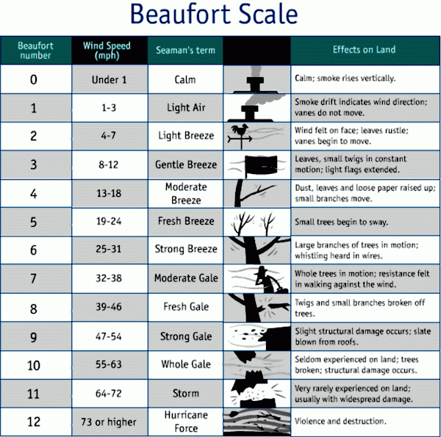

Hot Weather
A concern for safety occurs when air temperature exceeds 32°C and/or humidex reaches or exceeds 40.
When this environmental trigger occurs, crews will assess hazards. If the risks of heat disorders are high, the crew should make their way safely home.

Fire
If CRM staff encounter a fire, the following procedure should be followed:
- Assess the hazards in the area and determine the safety risks.
- Determine the safe evacuation routes.
- If it is safe to do so, work with the fire tools available in the crew truck to contain the fire.
- Where it is unsafe to work on the fire, get coordinates with handheld GPS or map, and leave the area
- Call the Kamloops Fire Centre and the Provincial fire hotline (numbers are provided on the emergency contact list)
- Describe the size and condition of the fire and relay the location.

Avalanche
CRM crews working in avalanche terrain during the winter must always carry avalanche beacons, probes and shovels. All individual working in avalanche conditions must have appropriate safety training that is equal to the AST standard employed by Avalanche Canada.
If an avalanche occurs and someone is buried, a preliminary scan of the area should be conducted with avalanche beacons. If this is not effective, a grid should be developed, and a beacon search should follow this grid. A probe search should commence once you close in on the beacon signal.

Wildlife Encounter Procedure

Bears

Response Matrix
Sign/Activity | Notify Crew | Evacuate Immediate Area | Muster | Continue Work
Tracks | Yes | No | No | Yes
Tree Marking | Yes | No | No | Yes
Digging | Yes | No | No | Yes
Scat | Yes | No | No | Yes
Bedding Sites | Yes | Yes | No | Yes
Bear Avoids Worker | Yes | Yes | No | Yes
Animal Carcass | Yes | Yes | No | No
Behaves Attacks  (With Cubs) | Yes | Yes | Yes | No

Basic Procedure
- Most bears make every effort to avoid humans. Make lots of noise when working or walking through the woods: talk, sing, bark, etc.
- Stay alert and be aware of your surroundings. Look for signs of bear activity. Bears will aggressively defend kill sites. Watch for birds circling or the smell of rotten meat or fish.
- Take your garbage with you.
- Avoid bringing fish such as tuna sandwiches for lunch.
- Always carry bear spray.

Bear Encounter
Try not to over-react – is it a black bear or a grizzly?
If you are planning to climb a tree, remember black bears can climb trees and grizzlies can climb short distances.
If it hasn’t noticed you:
Back away quietly the way you came. Stay downwind if possible.
If it has noticed you and doesn’t move towards you:
Move quietly upwind so it catches your scent. Don’t run. Look big by waving your arms slowly. Speak in a calm firm voice. Don’t act like prey. Bears stand on their back legs when trying to catch a scent. Bears can’t see well so you can pretend to be big.
If it approaches you or charges:
Stand your ground. Bears will often bluff a charge and suddenly back or veer off. Bears will try to scare you by huffing, snorting, panting, hissing, growling, and jaw popping. They will lower their heads and put their ears back. Females can be defending their young and any bear can be defending a kill.
If the bear defensively attacks (when surprised, feeding, or protecting its young):
Use bear spray. Aim at mouth or nose.
See Section 9.3 Bear Spray for more information on how to effectively use bear spray.
If it makes, contact with you:
Play dead, and lie flat on the ground face down, hands clasped behind your neck, and legs spread. (This provides you some protection and makes you harder to flip over).
Keep your coat or cruisers vest on it may afford some degree of protection.
Remain in this position for several minutes even if you think that the bear has gone away.
If the bear’s behavior is predatory or the attack goes from defensive to predatory:
Do not play dead. Act aggressively. Try to act dominant. Fight back!
Use bear spray and aim at mouth or nose.
Defend yourself with whatever is available a stick, an axe (aim for the nose).
Shout, blow your whistle, jump up and down, wave your arms, or wave your vest or coat.
After an attack, remain patient. After a few minutes try to determine if the bear is still in the area.

Additional Bear Safety Resources are available on the Q: Drive _Safety_> References > Bears

Cougars

Basic Procedure
- In cougar country make lots of noise when working/walking: talk, sing, roar like a tiger, etc.
- Avoid cougar kills. Cougars will cover a kill with dirt and debris and return to feed. Be alert for birds and other scavengers that might tip you off to a carcass and avoid dead animals in general.
- Carry an axe, shovel or walking stick for defense.
- Do not count on a dog to protect you. Aside from packs of well-trained lion hunting hounds, even large dogs have little or no value as a deterrent in cougar country (and they may lead a cougar back to you).

Cougar Encounter
- Do not run. Flight might trigger pursuit.
- Face the cougar. Do not turn your back on a cougar. Stand up.
- Maintain eye contact with the cougar. Cougars prefer to ambush prey from behind. If the cougar knows you have seen it, an attack is less likely.
- If you are working with a partner or crew use your radio to notify them that you have encountered a cougar. Let others within radio contact know your situation and location.
If the cougar is within 50 meters and is intensely staring and making an effort to hide or conceal itself:
Make yourself look bigger. Raise your hands overhead. If you have a jacket or a vest hold it up so you look even bigger and bulkier.
Attempt to move to safety. Do not run, but if there is a safer location (a vehicle) nearby, move toward it slowly while facing and watching the cougar. Try to get on higher ground than the cougar.
If the cougar is staring intensely, trying to hide, combined with crouching and/or creeping toward you:
Throw things at the cougar if it is close enough.
Smile. Show the cougar your teeth. To the cougar, you are displaying weapons.
Yell, shout, and make intimidating noises. Your goal is to convince the cougar that you are not prey, and may in fact be dangerous.
If a cougar is staring intensely, with its tail twitching, body low to the ground/crouching, and ears erect, the cougar is waiting for a chance to attack. If the cougar’s rear legs are also pumping or moving up and down and its ears are turned fur side forward, an attack is imminent:
Launch a pre-emptive strike by taking aggressive action toward the cougar.
If you have an ax or shovel use it. If you have a tree branch or stick, quickly run toward the cougar and shove the stick in its face. If you do not have a stick, yell and run toward the cougar with your hands overhead but stop before you are within reach of its paws.
If a cougar attacks and makes contact:
Fight for your life. Use any weapon available (ax, shovel, increment borer, stick, knife or your fists). Direct your blows to the cougar’s eyes, nose, ears, and face.

Biological Hazards

Infectious Diseases
In the event of an infectious disease hazard, Cabin will develop a response and best management plan specific to the hazard to provide the most effective system possible.
Currently Cabin Infectious Disease Response Plans have been created for the COVID-19 Pandemic and can be found on the Q: Drive >Safety> COVID-19.

Sharps Identification and Disposal
When working in city areas where there is risk of biohazards such as discarded needles, the following procedure should be followed:
City park staff does a sweep prior to commencement of work.
Steel toed boots and thick rubber gloves are mandatory when working in areas with thick brush or ground cover. Gloves will be supplied. See 9.2 Personal Protective Equipment.
Clean up all garbage and/or clear our safe working area.
Once a safe working area has been established we do not work outside that area.
If a biohazard is found, do not touch it. Quarantine off the area.
Contact a principal and the client contact. City staff will be dispatched to remove any paraphernalia within 24 hours.
If someone is exposed to blood and other body fluids, seek immediate medical attention within two hours.

Emergency Procedures
- Assess the potential hazards during routine site inspections and determine the risks and possible procedures that would be applicable. Site inspections should be performed for all new sites as well as when conditions change. Site inspection forms are available on the Q: Drive :_Safety_>!Safety Forms and will be submitted to _Safety_>!Submit Forms Here
- Design an evacuation plan for all project areas.
- Conduct periodic evacuation and emergency response drills and system tests.
If the CRM Safety Plan does not sufficiently address the hazards and risks on site, develop a site-specific Emergency Response Plan (ERP). The ERPs will provide a list of contact numbers, helicopter landing locations, and ambulance muster locations. These ERPs should be available in the crew truck, as well as on SD cards of company provided phones and are available on the Q: Drive (_Safety_> ERP’s). These ERP’s should be reviewed and updated yearly.

Responding to Emergencies
If an emergency occurs that requires immediate medical response and/or evacuation:
- Assess the situation
  - Determine if any sources of danger to you are present before assisting with an injured person. First responders should never run in to assist if it can lead to them becoming injured.
  - What kind of response is required and the severity of the situation?
- Determine a course of action
- If required, perform basic first aid; ensure that the victim is warm, dry and their condition is stable.
- Contact emergency services
- If the victim must be left, flag your way out of the bush and mark their exact location on a map and with handheld GPS in order to aid rescue personnel. Once you reach the truck, use the two-way radio, cell phone or repeater channel to call for help. If you cannot contact anyone, try using a radio relay via another party (logging trucks), which may be able to offer or contact assistance.

- Give directions on where you are, how to locate the victim and the method of transport required (ambulance, stretcher, helicopter, or winch assist/long line helicopter rescue)

- If an ambulance is requested

- If the injured person cannot be moved and/or is in a remote location air evacuation may be necessary. Request the North Okanagan Search and Rescue Winch Rescue Helicopter Team.

Patient Information Required by Emergency Services
- Precise location of the patient
- Age and sex of the patient
- Mechanism of injury
- Patient’s chief complaint(s)
- Vital signs
- Suspected diagnoses
- Treatment rendered
- Special equipment or personnel needed
- ETA
- If a rendezvous for ambulance is requested

Air Evacuation
Although air travel is faster, it may take significantly longer to organize an air evacuation and then await the aircraft’s arrival. It is best to use air transport for seriously injured patients if the total time saved is 30 minutes or more if the situation warrants it (life or death).
Prior to aircraft arrival:
- Remove all loose debris from landing site
- If necessary, set up road blocks 0.5km away from landing
- Optional: light a signal flare or fire away from actual landing site.

Safety Procedures around helicopters:
- The Supervisor, Attendant and all assistants must wear eye protection (goggles or face shields) during takeoff and landing.
- Remove or fasten loose clothing (i.e. hats, jackets)
- After touchdown, await the pilot’s instructions or signal before approaching.
- Approach or leave helicopters from the front or side, within the pilot’s field of vision.
NOTE: On sloped terrain, approach or leave on the downslope side to avoid the main rotor
NEVER approach or leave a helicopter from behind.
- Crouch when approaching or leaving the helicopter.
- Never carry anything above shoulder height
- Patient should not be carried or lifted above waist height

Rescue Procedure for Missing or Late Personnel
If an individual or crew is late in returning after the E.T.A., the following procedure will be employed:
- The contact person (Project Managers) for CRM will try to contact the missing crew or person upon expiry of 15 minutes after the ETA.
- If there is no contact with the missing crew after 30 min, then a Principal will be telephoned, and preliminary evaluation of the situation will commence. (i.e. get ready to sound the alarm). A marshalling point should be determined at this stage.
- If the crew cannot be contacted and is still missing after 60 minutes, the principal and the client contact person will pool all available personnel including Search and Rescue and will coordinate a search to commence at the marshalling point at a set time, where search personnel will be briefed on the situation.
- The CRM and client staff will proceed with a field search if search and rescue personal are not able to mobilize as fast as CFRM staff. One person must remain at the marshalling point to guide search and rescue to the site.
- It is preferred that the local search and rescue organization take over the search when they arrive on site. All CRM and client staff members will provide support when the search and rescue members arrive on site.
- The two-way radio “road channel” for the area the individual or crew is working will be monitored as the rescue parties head out to try and make contact and determine the reason for the late return.
Emergency Contacts are located in Appendix H.
All Employee Contacts are listed on the Q: Drive Safety > Employee Contact List

Fatality Emergency
A copy of all employees and subcontractor Emergency contact information is kept posted on the wall in Cabin office locations, and posted on the CRM Q:Drive. >Safety>Employee Contact List. In the event of a CRM work or travel related fatality:
- Assess the accident scene if safe to do so. Leave immediately if it is unsafe to remain at the scene.
- Cover the victim in a suitable fashion.
- Leave the accident scene exactly as it is for the subsequent accident investigations by WorkSafeBC and the RCMP.
- Document location: Block number, road access information, and the UTM coordinates for remote sites. Flagging from the accident site may be required to help aid investigators and the RCMP.
- Once the scene has be turned over to Cabin by WorkSafeBC and the RCMP, do not move or alter anything until the JOHSC has completed their internal investigation.
Cell Phone Service Area
  - Call 911 and inform the operator of the accident. The 911 operator will then dispatch the appropriate emergency services.
Radio: Radio messages cannot use the victim’s name and should not use any words which tell anyone that there has been a fatality (Examples include died, killed, etc.). Cabin Resource Management or subcontractors should say the following phrase when using the radio to identify among crew members that there has been a fatality: “The day is over meet me at (location)”. Radio contact procedure:
  - Attempt to relay a message via vehicle or handheld radio.
  - Attempt to contact Tolko Southern Interior Woodlands Office by using the Tolko repeater for the area.
No Radio Contact
- If unable to contact anyone via radio, the witness will then seek help by radio contact by driving to a location where they can call for help.
- The project manager or other employees on site must take notes, photos, document time of fatality (if known) and cause (if known). Notes are taken to assist in accident investigation and to assist in the development and improvement of Cabin Forestry standard safe operation procedures.
- Complete an incident report immediately and forward a copy to Kyle Broome (Owner Representative) or Keenan Clark (CRM Safety Coordinator).
- Kyle Broome (Owner Representative) or Keenan Clark (CRM Safety Coordinator) must immediately fill out an Incident Investigation form.
- Notify WorkSafeBC Prevention Emergency Line – 1-888-621-7233. CRM Work Safe BC #691565.
- Notify a client supervisor and the contract representative if they are not on site.
- Emergency numbers are located in Appendix H of the Cabin Safety Plan
- Kyle Broome (Owner Representative) or Keenan Clark (CRM Safety Coordinator) are to make arrangements to notify the next of kin in person using the Emergency Contact information collected from each employee.
- Statements to the press or other outside parties are to be made by Kyle Broome only

Office Emergency Procedure
- Remain calm. Alert others of the alarm.
- The person who grabs the Visitor Sign-In sheet will assume the duty of Emergency Coordinator
- Emergency Coordinator will be responsible to ensure all rooms, washrooms, office storage and the hallway storage is clear of people. Emergency coordinator may direct personnel to assist in checking those areas.
- Promptly evacuate to Emergency Meeting Area using routes as outlined in Emergency Escape Routes Map that is posted on the wall.
- Close all fire doors as you exit the building. Do not lock the doors.
- Call 9-1-1

Emergency Safety Drills
- Workplace safety drills will help employees be prepared in case of emergency. To ensure emergency preparedness amongst crews, employees will participate in at least one Emergency Safety Drill per year. A documented scenario and proof of completion will be retained for future learning purposes.
- Safety Drills will be evaluated using Emergency Drill Evaluation form.
- Additional office fire drills will occur annually and will be recorded in the emergency drill tracking sheet.

Roles and Responsibilities
PERSONNEL | TASK
Principal | Ensure Project Managers comply with documented safety procedures. Complete disciplinary action for non-compliant staff and contractors. Contact the client, RCMP or Search & Rescue in the event or a major incident or fatality.  Client liaison.
Safety Coordinator | Incident investigation leader  Provide training on emergency procedures, evacuation methods to all staff.  Develop emergency procedures and evacuation protocol, and complete annual review and revise when necessary.  Produce a contact list with key emergency numbers and client contact numbers\  Ensure training and certifications are up to date.
Project Manager/Site Supervisors | Emergency response team leader  Responsible for completing regular site inspections, safety audits, and assessing workplace hazards. Design and update ERP’s to suit current site conditions.
Employees | Senior and Mid-level staff must have OFA Level 1 first aid. All staff are responsible for maintaining their BC Personal first aid kit.  Cabin fleet operators must maintain BC level 1 first aid kits in their vehicle and ensure contents are properly stocked.  Can initiate the emergency response protocol (leave unsafe area/conditions; contact principal; first aid)

Investigations
- Any investigation into accidents, incidents, and close calls will be documented using Cabin’s internal Incident Reporting form in conjunction with WorkSafeBC’s investigation template. All completed investigations will be maintained in the CRM safety filing system.
- Investigations must be conducted by a properly trained and competent individual. Multiple staff must be trained to complete incident investigations at any given time. Training records will be maintained by Cabin for reference purposes.
- Individuals involved in the incident may not be a part of the investigation team.
- Discussion and analysis of the documented accidents, incidents, or close calls will be used to determine the immediate and root causes
- Preliminary investigations must be completed within 48hrs of the incident occurring and full investigations completed within 30 days. Full investigation report are to be submitted to WorkSafeBC via the EIIR upload portal and retained by Cabin for recording purposes.
- Investigations will be described in detail and additional learnings will be presented at the following JOHSC meeting and safety meeting document.
- Safety awareness and improvements to the safety plan should be pursued through review of the accident, incident, and close call reports.

Staff Competency and Professional Development Plans
Professional Development Plans will be tailored to advise, coach and evaluate the performance of all supervisors and workers.
- All employees and dependent contractors will be assessed on all tasks that they may be required to carry out as part of their job description. If they are deemed to have insufficient skills to perform a task, they will receive in-house training from a project manager to bring their skills up to a level where they are deemed to be competent. Where more formal training is required, this will be arranged through a certified instructor, (i.e. Level 1 first aid).

- All employees and dependent contractors will receive either in-house training or, if it is required, formal training prior to performing a new task.

- A record of Employee Training and Certification for all CRM workers will be kept on file. Certification and references will be verified prior to any new worker starting work with CRM.

4. CRM knows the importance of a knowledgeable and competent workforce. With this in mind, a yearly training allowance will be set aside for each employee to allow them to receive formal training to improve their skill set. In addition, in-house CFS mentoring will occur whereby project managers share knowledge with senior and junior technicians.

5. Project Managers will evaluate worker competency throughout the year and feedback will be provided on an ongoing basis. There will also be a year-end competency review and discussion between each worker and the company owner(s).

Health and Wellness
- CRM is committed to establishing a health and wellness program for all employees.
- The health and wellness program will promote participation in physical activities aimed at improving the physical and mental health of CRM staff.
- Company activities (i.e. fishing trips, barbecues, and golf games) will occur periodically throughout the year.
- All employees must present for documentation all known health problems, allergies and ailments prior to commencement of work.
- Any employee experiencing stress/duress that has a negative impact on their ability to work, general health or the “crew environment” should discuss the matter with one their project manager and an ownership representative.

Fatigue
We recognize that employee fatigue can result in decreased cognition, increased incident risk and decreased productivity. Work and workplace conditions such as working outdoors, long hours, heavy PPE, exposure to extreme cold or heat, and/or dehydration can increase a worker’s susceptibility to fatigue. Fatigue and its effects are made worse by simple or monotonous task such as driving to and from the worksite. Workers too fatigued to drive safely may present a hazard to themselves and others.
In the event of fatigue or burn out, Cabin will take all steps available to ensure that the employee can continue to work (ie: light duty, office tasks, modified tasks). Cabin, at the discretion of the JOHSC and ownership, will also provide additional unpaid time off in the event that people require additional time to recover outside of work.
Measures to manage fatigue will include:
  - Training and mentorship
  - People can take unpaid personal days
  - Shared driving on long drives.
Additional Resources available on the Google Drive: _Safety_> References > Fatigue

Injury/Disability Management
CRM understands that health conditions, illness or serious injuries can lead to short term and long term disabilities that prevent employees from working. With this in mind, CRM provides a benefit package for all permanent employees that have worked with the company for at least 6 months. The benefit package provides short term disability coverage for injuries that occur outside of work (i.e. broken leg playing hockey), where the employee is expected to return to work within 17 weeks. In addition, there is long term disability coverage that takes care of employees for up to 5 years where there is no possibility of a return to work due to a career changing injury or illness that leaves an employee disabled or unfit to carry on with daily forestry activities. Any injury or illness that occurs at work or from long term exposure to harmful conditions at work should be covered by WorkSafeBC.
Any employee that is recovering from an injury or illness and is attempting to return to work will be provided with options for light duty tasks, office work and some opportunity for re-training. There will, however, be limitations to the amount of re-training available. The goal is to make sure that all employees returning from time off due to an illness or an injury can function well and remain healthy.

Appendix A. LIABILITY POLICY

Company Perspective

Cabin Forestry Services Ltd’s (dba: Cabin Resource Management) (the company) consideration towards company liability is as follows:

- Registered Professional Foresters employed directly by the company or through subcontract will carry a current policy of Professional Liability Insurance including available compensation of up to an aggregate of
$ 1,000,000 errors and omissions insurance per annum.

- A condition of employment with the company will be that all employees have read this document and our company safety policy. Subcontractors working through our company must also verify that they carry adequate and suitable liability insurance.

- All vehicular transportation used for company business will be insured in the appropriate class of coverage and will include third party liability insurance to a minimum value of $ 2,000,000.

- The company will operate as a legally registered corporation.

- The company will be at all times registered and in good standing with the Workers’ Compensation Board of B.C.

- It is the company preference to engage in a standard limited works contract in agreement with the client, prior to work commencing on any project.

- Financial liability in the company name will be insured against the unforeseen event where default is unavoidable.

- The company will carry Commercial General Liability Insurance in a broad form package with compensation available up to $ 3,000,000 including a provision for forest fire coverage.

- Due diligence will be promoted within the company necessitating pre-work conferences with clients and regular communication during ongoing projects. Periodic safety meetings will be held and project managers and company principals will carry out close monitoring of general company performance jointly.

- All employees are prohibited from smoking or lighting fires of any kind outside of a strictly controlled environment (i.e. camp stove) while on the job or job site.

The company reserves the right to add considerations, modify this document as required or otherwise take action to protect itself from any liability mentioned above or not.

Steve Milne, R.P.F. Kyle A. Broome, R.P.F. Trevor Rasmussen, R.F.T. Mike Crone, R.P.F.
Founding Partner Principal Partner Partner

Appendix B. WHMIS 2015 Pictograms
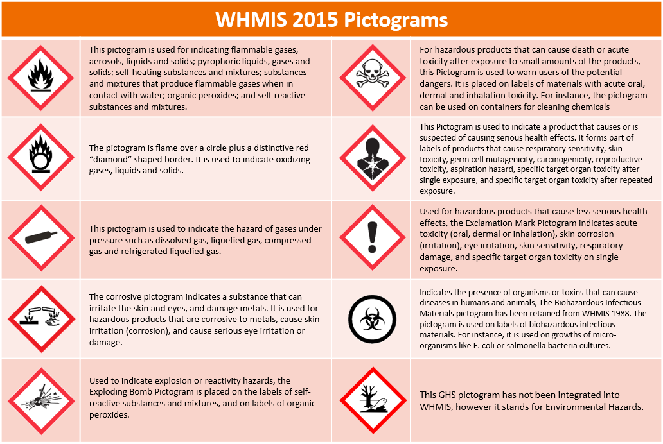

Appendix C. First Aid Kit Checklist

BC Level 1 Personal First Aid Kit
These items must be kept clean and dry. A weatherproof container is recommended.
ITEM | QTY
REQUIRED
☐ Pressure dressing | 1
☐ Sterile adhesive dressings, assorted sizes, individually packaged | 6
☐ 14 cm x 19 cm wound cleansing towelettes, individually packaged | 6
☐ Instruction card advising the worker to report any injury to the employer | 1
RECOMMENED
☐ Antihistamine or Allergy Drops | 1

BC Level 1 First Aid Kit
These items must be kept clean and dry and must be ready to take to the scene of an accident.
Blankets should be readily available to the first aid attendant.
ITEM | QTY
☐ Blankets | 1
☐ 14 cm x 19 cm wound cleaning towelettes, individually packaged | 24
☐ Sterile adhesive dressings, assorted sizes, individually packaged | 50
☐ 10 cm x 10 cm Sterile gauze dressings, individually packaged | 10
☐ 10 cm x 16.5 cm Sterile pressure dressings with crepe ties | 4
☐ 7.5 cm x 4.5 m Crepe roller bandages | 2
☐ 2.5 cm x 4.5 m Adhesive tape | 1
☐ Quick straps (a.k.a. fracture straps or zap straps) | 2
☐ Cotton triangular bandages, minimum length of base 1.25 m | 2
☐ Safety pins | 4
☐ 14 cm Stainless steel bandage scissors or universal scissors | 1
☐ 11.5 cm Stainless steel sliver forceps | 1
☐ Cotton tip applicators | 12
☐ Pocket mask with a one-way valve and oxygen inlet | 1
☐ Pairs of medical gloves (preferably non-latex) | 6
☐ Waterproof waste bag | 1
☐ Windlass style tourniquet | 1
☐ First aid records and pen

Appendix D. PPE Inspections

Does Your Hardhat Need Replacing?
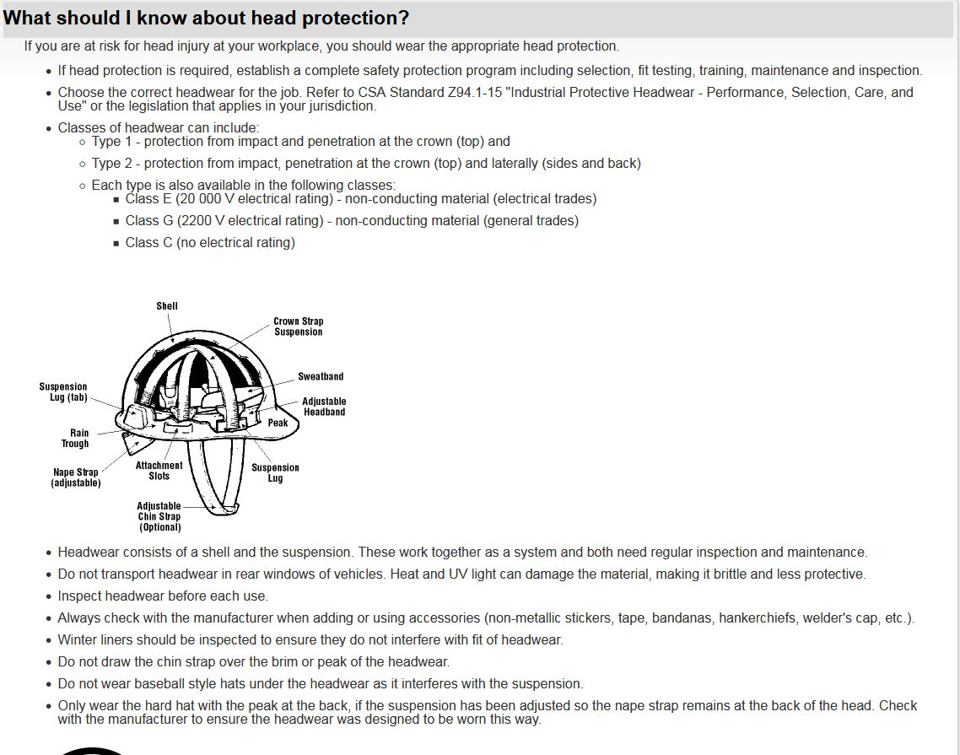
The hardhat is one of the most important pieces of PPE. Exposure to temperature extremes, direct sunlight, or chemicals (such as fire retardant or tree marking paint) can shorten the useful life of a hard hat. We should be checking our hard hats daily for dents, cracks, nicks, gouges, and any damage that might reduce protection. Clean the suspension and shell regularly according to manufacturer instructions. Replace once struck even if there is no visible damage. The use of stickers should be avoided so cracks and defects can be easily seen.
https://www.ccohs.ca/oshanswers/prevention/ppe/headwear.html
Corrective Actions:
If there is any damage to the shell or the suspension, then it should be replaced right away.
If the hardhat shell becomes stiff, brittle, faded or appears dull or chalky, is a sign to replace the hardhat.
A good working hardhat shell can be subjected to compression with your hands from both sides about 2 cm. Upon release the shell should return to its original shape quickly, exhibiting elasticity. It is good to compare with a newer shell if available. If the shell tested does not exhibit much elasticity or if the shell cracks, it should be replaced immediately.

Appendix E. Radio Channel Frequencies
Okanagan  16-Channel Handheld Radio |  |  |  |  |  |  |  |  |  |  | Nakusp/Kootenays  16-Channel Handheld Radio
LABEL |  |  | Channel |  |  | Rx/Tx |  |  |  |  | LABEL |  |  |  | Channel | Rx | Tx
Tolko |  |  | 1 |  |  | 153.050 |  |  |  |  | Interfor 1 |  |  |  | 1 | 153.350 | 153.350
Riverside |  |  | 2 |  |  | 153.230 |  |  |  |  | Interfor 2 |  |  |  | 2 | 157.260 | 157.260
Riverside A |  |  | 3 |  |  | 153.260 |  |  |  |  | Interfor 3 |  |  |  | 3 | 156.240 | 156.240
Riverside L |  |  | 4 |  |  | 153.440 |  |  |  |  | Interfor 4 |  |  |  | 4 | 154.665 | 154.665
RVSchmidt |  |  | 5 |  |  | 153.380 |  |  |  |  | Interfor 5 |  |  |  | 5 | 153.320 | 153.320
Weyco |  |  | 6 |  |  | 153.530 |  |  |  |  | Lad 1 |  |  |  | 6 | 154.100 | 154.100
(Cabin) Gorman |  |  | 7 |  |  | 154.250 |  |  |  |  | (Cabin) Gorman |  |  |  | 7 | 154.250 | 154.250
LD-1 |  |  | 8 |  |  | 151.700 |  |  |  |  |  |  |  |  | 8 | 150.485 | 150.485
LD-2 |  |  | 9 |  |  | 151.745 |  |  |  |  |  |  |  |  | 9
LD-3 |  |  | 10 |  |  | 151.790 |  |  |  |  |  |  |  |  | 10
LD-4 |  |  | 11 |  |  | 151.805 |  |  |  |  |  |  |  |  | 11
LD-5 |  |  | 12 |  |  | 151.850 |  |  |  |  | BALDY |  |  |  | 12 | 152.225 | 157.320
YEOWARD |  |  | 13 |  |  |  |  |  |  |  | BLUE JOINT |  |  |  | 13 | 152.450 | 157.380
BUCK |  |  | 14 |  |  |  |  |  |  |  | NORTH |  |  |  | 14 | 153.560 | 154.600
TERRACE |  |  | 15 |  |  |  |  |  |  |  | CENTRAL |  |  |  | 15 | 153.620 | 152.930
FLY |  |  | 16 |  |  |  |  |  |  |  | SOUTH |  |  |  | 16 | 157.470 | 158.370

128-Channel VHF Transceiver Truck Radio
128-Channel Handheld Radio
BANK I |  |  | BANK II |  |  | BANK III
LABEL | Rx/Tx |  | LABEL | Rx/Tx |  | LABEL | Rx/Tx
RR-1 | 150.080 |  | BUCK |  |  | 150-815 | 150.815
RR-2 | 150.110 |  | TERRACE |  |  | 151-610 | 151.610
RR-3 | 150.140 |  | FLY |  |  | 151-685 | 151.685
RR-4 | 150.185 |  | YEOWD |  |  | 152-285 | 152.285
RR-5 | 150.200 |  |  |  |  | 152-900 | 152.900
RR-6 | 150.245 |  |  |  |  | 152-975 | 152.975
RR-7 | 150.260 |  |  |  |  | 153-020 | 153.020
RR-8 | 150.320 |  |  |  |  | 153-050 | 153.050
RR-9 | 150.365 |  |  |  |  | 153-200 | 153.200
RR-10 | 150.410 |  |  |  |  | 153-230 | 153.230
RR-11 | 150.440 |  |  |  |  | 153-260 | 153.260
RR-12 | 150.500 |  |  |  |  | 153-320 | 153.320
RR-13 | 150.530 |  |  |  |  | 153-350 | 153.350
RR-14 | 150.545 |  |  |  |  | 153-380 | 153.380
RR-15 | 150.560 |  |  |  |  | 153-440 | 153.440
RR-16 | 150.590 |  |  |  |  | 153-470 | 153.470
RR-17 | 150.680 |  |  |  |  | 153-530 | 153.530
RR-18 | 150.710 |  |  |  |  | 153-560 | 153.560
RR-19 | 150.770 |  |  |  |  | 153-620 | 153.620
RR-20 | 150.830 |  |  |  |  | 153-830 | 153.830
RR-21 | 151.010 |  |  |  |  | 154-100 | 154.100
RR-22 | 151.130 |  |  |  |  | 154-250 | 154.250
RR-23 | 151.190 |  |  |  |  | 154-325 | 154.325
RR-24 | 151.220 |  |  |  |  | 154-665 | 154.665
RR-25 | 151.310 |  |  |  |  | 156-240 | 156.240
RR-26 | 151.340 |  |  |  |  | 156-375 | 156.375
RR-27 | 151.370 |  |  |  |  | 157-260 | 157.260
RR-28 | 151.430 |  |  |  |  | 157-320 | 157.320
RR-29 | 151.460 |  |  |  |  | 157-400 | 157.400
RR-30 | 151.490 |  |  |  |  | 157-560 | 157.560
RR-31 | 151.520 |  |  |  |  | 158-130 | 158.130
RR-32 | 151.580 |  |  |  |  | 158-190 | 158.190
RR-33 | 151.610 |  |  |  |  | 158-940 | 158.940
RR-34 | 151.640 |  |  |  |  | 162-120 | 162.120
RR-35 | 151.670 |  |  |  |  | 162-330 | 162.330
LD-1 | 151.700 |  |  |  |  | 162-840 | 162.840
LD-2 | 151.745 |  |  |  |  | 165-960 | 165.960
LD-3 | 151.790 |  |  |  |  | 169-650 | 169.650
LD-4 | 151.805 |  |  |  |  | 173-370 | 173.370
LD-5 | 151.850

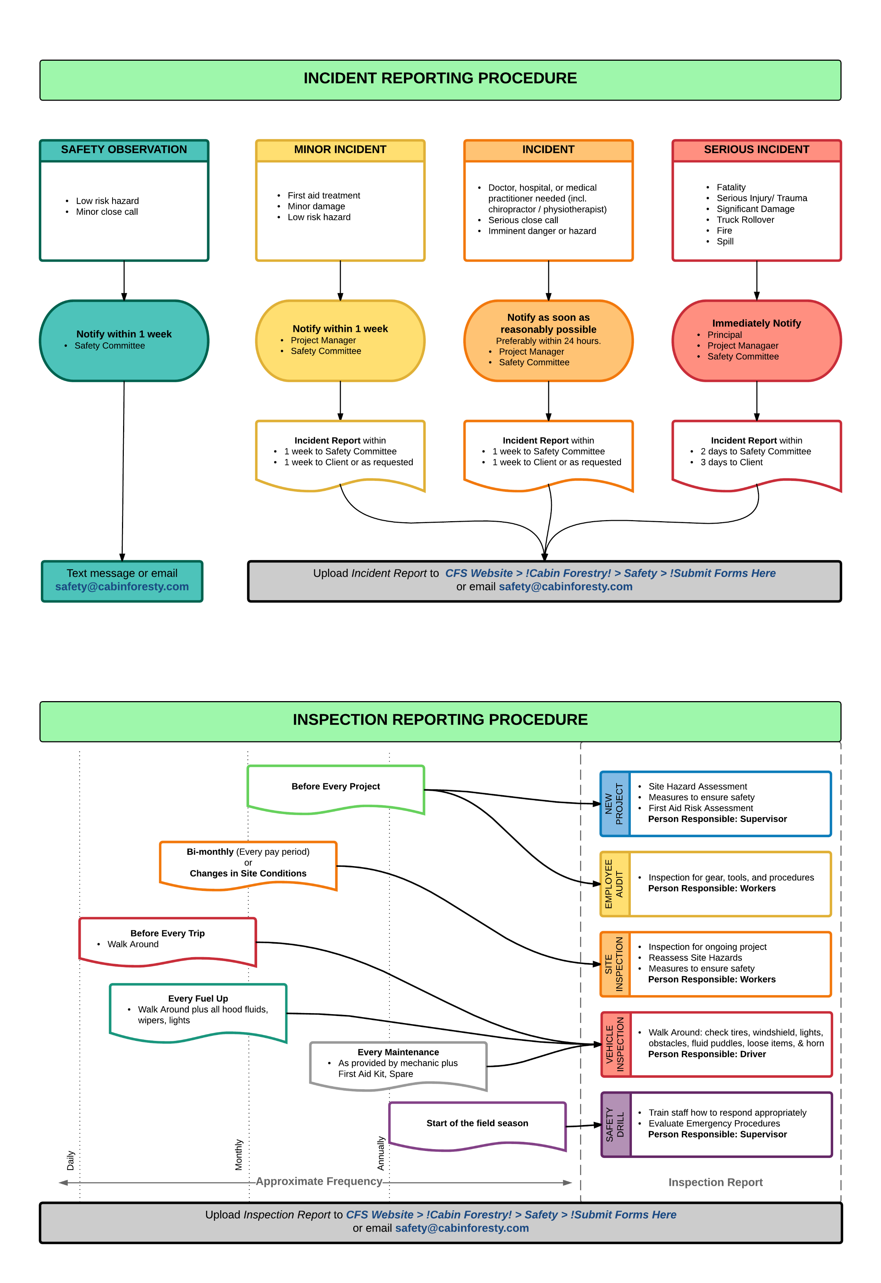
Appendix F Inspection Reporting Procedure

Appendix f. Incident Reporting Procedure

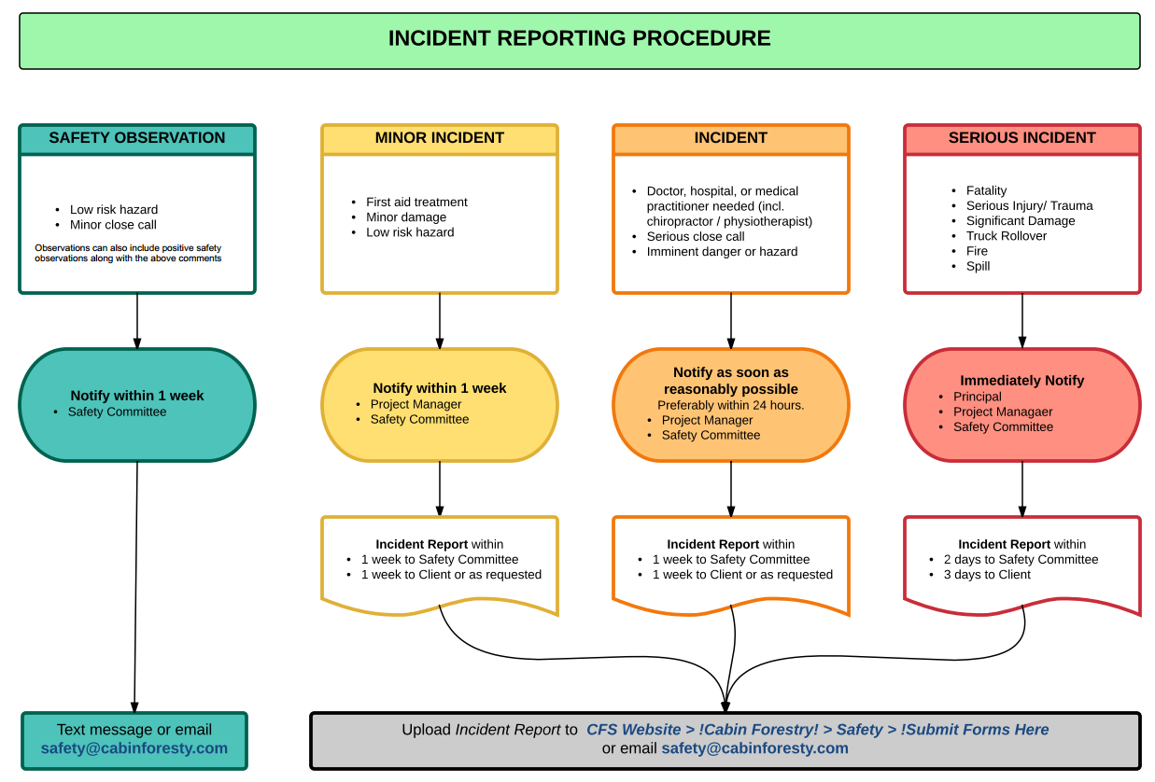
Appendix g. Emergency Contact List Emergency Contact Numbers
Emergency Contact List
Police, Fire, Ambulance |  | 911
RCMP Search & Rescue |  | 911
Forest Fires | 1-800-663-5555 or *5555 on your cell phone | (Non-Emergency)
Kamloops Fire Centre | 250-554-5500 | RCMP Vernon | 250-545-7171
Southeast Fire Centre | 250-365-4040 | RCMP Kelowna | 250-762-3300
Poison Control Centre | 1-800-567-8911 | Nelson Police Dept. | 250-354-3919
FortisBC (GAS) | 1-800-663-9911
Spill Reporting | 1-800-663-3456 | WORKSAFE BC
BC Hydro | 1-888-769-3766 | Okanagan | 1-888-922-4466
Nelson Hydro | 1-877-324-9376 | West Kootenays | 1-800-663-4692
FortiBC (Electrical) | 1-800-436-7847 | Richmond | 1-800-621-7233
 |  | RDNO (North Okanagan) | 1-250-550-3700
CFS Staff Contacts |  | RDCO (Central Okanagan) | 1-250-763-4918
Cabin Forestry - Vernon | 778-475-3655 | RDCK (Central Kootenay) | 1-250-352-6665
Cabin Forestry - Castlegar | 778-460-4430 | CRD (Cariboo) | 1-250-392-3351
Steve Milne | C: 250-308-4288 | Hospital & Medical Centres
 | H: 250-766-7235 | Vernon | 250-545-2211
Kyle Broome | C: 250-826-1623 | Kelowna | 250-862-4000
 | H: 250-764-2954 | Penticton | 250-492-4000
Trevor Rasmussen | C: 778-212-1488 | Castlegar | 250-365-7711
Mike Crone | C: 250-307-1869 | Merritt | 250-378-2242
Keenan Clark | C: 250-309-2847 | Sparwood | 250-425-6212
Mike Jobke | C: 250-540-6814 | New Denver | 250-358-7911
Jack Toma | C: 250-309-7236 | Williams Lake | 250-392-4411
David Strahl | C: 778-212-4088 | 100 Mile House | 250-395-7600
Brody Jordan | C: 250-265-7006
Keith Tucker | C: 250-309-8816
Thomas Martin | C: 778-869-7730
Client Contacts
Tolko (Monashee Area):  Travis Dunbar | 1-250-547-1317 | Tolko (Kamloops Area):  Ted Swab | 1-250-861-6916
BCTS Arrow North:  Doug MacPherson |  | West Fraser Sundre: Ed Wassink | 1-403-638-6202
BCTS OK/Shuswap:  Joanna deMontreuil |  | Neskonlith Indian Band: Shane Vincenzi | 1-778-220-3292
BCTS OK/Shuswap: Warren Yablonsky | 1-250-558-1724 | Interfor Grand Forks:  Evan Dutka | 1-250-304-6416
BCTS Boundary:  Brad White | 1-250-354-8172 | Interfor Castlegar:  Simon Martin | 1-250-365-4408
BCTS 100 Mile:  Robert Nash | 1-250-395-7870 | Interfor Adams Lake:  Erik Kok
Kalisnikoff Lumber:  Gerald Cordeiro | 1-250-304-4485

Appendix h. WSBC First Aid Requirements

Table 1: This table applies to a workplace that an employer determines under section 3.16 (2) (b) of the Regulation creates a low risk of injury and that is more than 20 minutes surface travel time away from a hospital
Number of workers per shift | Supplies, equipment, and facility | Level of first aid certificate for attendant | Transportation
1 | Personal first aid kit |  | N/A
2-5 | Basic first aid kit |  | N/A
6-30 | Level 1 first aid kit | Level 1 certificate | N/A

Table 2: This table applies to a workplace that an employer determines under section 3.16 (2) (b) of the Regulation creates a low risk of injury and that is 20 minutes or less travel time away from a hospital.
Number of workers per shift | Supplies, equipment, and facility | Level of first aid certificate for attendant | Transportation
1 |  |  | N/A
2-10 | Basic first aid kit |  | N/A
11-50 | Level 1 first aid kit | Level 1 certificate | N/A

Table 3: This table applies to a workplace that an employer determines under section 3.16 (2)(b) of the Regulation creates a moderate risk of injury and that is more than 20 minutes away from a hospital.
Number of workers per shift | Supplies, equipment, and facility | Level of first aid certificate for attendant | Transportation
1 | Personal first aid kit |  | N/A
2-5 | Basic first aid kit | Level 1 certificate | N/A
6-15 | Level 1 first aid kit  ETV equipment | Level 1 certificate with Transportation Endorsement | N/A

A female representative will be required on the JOHSC when company composition permits (25% of workforce is female).
Dependent contractors will be treated as employees and will be required to adhere to all applicable Cabin Forestry policies*
Minimum one certified first aid attendant per worksite.
Digital copies of certifications will be retained by CFS and are available by request.
Fuel up and pre-trio inspections should be completed when vehicles or mobile equipment are used to access the worksite. Completed forms to be submitted monthly.
Manufacturers recommend 5-7 year lifespans for protective headwear. This can be compromised by chemical and UV exposure as well as damage. Appropriately, there is definitive lifespan for protective headwear and may require replacement prior to the recommended intervals.
Applicable to commercial vehicles with a GVWR of 12000kg or greater.
Two or more staff should hold up to date incident investigation training certification at any given point throughout the course of the year.

